Selective Repeat ARQ (Solved Problem 2)

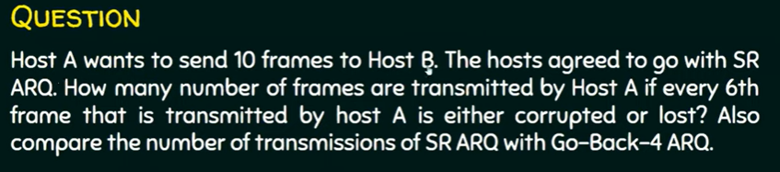



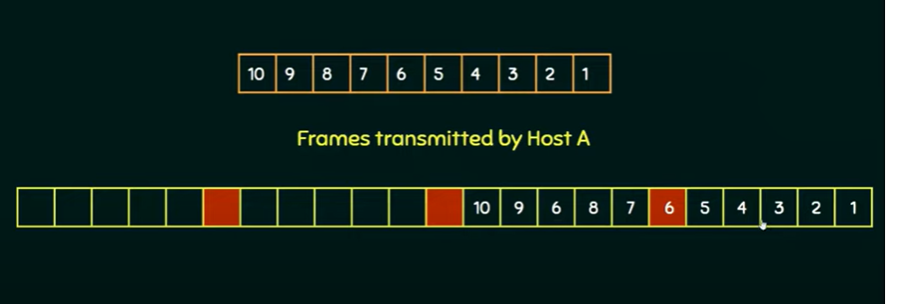

**Answer: 11**